Multi-functions CCTV Tester

TECHNOLOGY

HD-3000 series︱4K HD camera test

5 inch 4 IN 1 HD CCTV Tester
● 5 inch TFT-LCD screen, 800*480 resolutions
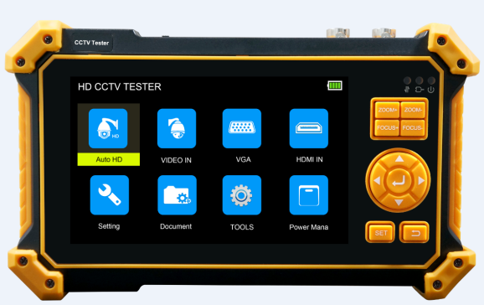
● 8MP CVI/ TVI/ AHD camera test
● 8MP EX-SDI, HD-SDI, 3G-SDI test*
● VGA input, support 1920 x 1200P 60FPS
● HDMI Input, support 4K 30FPS
● Analog camera test, PAL/NTSC auto adapt
● Auto HD, auto recognize HD coax camera type and resolution
● DC12V 1A power output
● DC 5V 1A power output, support reading USB disk
● UTP cable test, detect the near-end, mid-end and far-end fault point
of the network cable crystal head
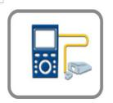
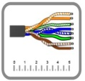
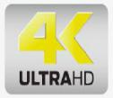

Application

The 5 inch TFT-LCD screen HD CCTV tester is designed for maintenance and installation of HD coaxial cameras, UTP cable test as well as other security equipment. The 800*480 resolution enables it to display HD cameras and analog cameras in high resolution. CCTV installers often need to carry a variety of testing tools to complete their work. If take the all in one camera tester, making working conditions safer and increasing productivity.
CCTV system installation and maintenance
Network cabling project installation and maintenance
TVI CVI AHD SDI camera testing
PTZ controller
Features

Camera test:
● 5 inch TFT-LCD screen, 800*480 resolutions
● 8MP TVI test, 3840 x 2160P 12.5/15 FPS, coaxial PTZ control & call OSD menu
● 8MP AHD test, 3840x2160P 15 FPS, coaxial PTZ & call OSD menu
● 8MP CVI test, 3840 x 2160P 12.5/15FPS, coaxial PTZ & call OSD menu
● 8MP EX-SDI test, 3840 x 2160P 25/30FPS, coaxial PTZ & call OSD menu*
● HD-SDI test, 1920 x 1080P 25/30/50/60 FPS, coaxial PTZ & call OSD menu*
● 3G-SDI test, 1920 x 1080P 50/60 FPS, coaxial PTZ & call OSD menu*
● Auto HD app, auto recognize HD coax camera type and resolution, support coaxial PTZ & call OSD menu.
● VGA input, up to 1920 x 1200P 60FPS, support snapshot, video record& playback.
● HDMI Input, up to 4K 30FPS, support snapshot, video record& playback.
● CVBS camera test, PTZ controller
● DC12V/1A power output, camera can be powered from DC 12 Voltage.
● DC 5V 1A power output, support reading USB disk

Cable test:
● Improvement cable tester, UTP cable, telephone cable etc order and connectivity test, can save testing report, if special number, need customized. Can detect the near-end, mid-end and far-end fault point of the network cable crystal head.
● Digital Cable tracer, search BNC cable, network cable and telephone cable from the mess cables. Cable search and UTP cable can test at the same time *
Other Functions:
● Media player, video files and MKV/MP4 media files play
● High brightness LED light
● Audio in, test whether sound normal.
● Power manager function, view 12V supply voltage and power in real time, can detect whether the voltage and power of DC 12V power output is normal.
● 3.7 V /5200mAh Lithium Ion Battery, after 4 hours charging, working time lasts 6.5 hours

Specification

LCD | Item series | HD-3000 series
 | Display | New 5 inch TFT-LCD screen, 800*480 resolution
Video Mode | CVBS | 1 channel BNC input, NTSC/PAL (Auto adapt)
 |  | PTZ control, RS485 control, Baud 600-115200bps, compatible with more than 30 protocols such as PELCO-D/P, Samsung, Panasonic etc
 | HD Coaxial test | 8MP TVI camera test, 3840 x 2160P 12.5/15 FPS, UTC control/ call OSD menu
 |  | 8MP CVI camera test, 3840 x 2160P 12.5/15 FPS, UTC control / call OSD menu
 |  | 8MP AHD test, 3840 x 2160P 15FPS, UTC control / call OSD menu
 |  | 8MP EX-SDI, HD-SDI, 3G-SDI, UTC control / call OSD menu *
 |  | Auto HD app, auto recognize HD coax camera type and resolution, support coaxial PTZ & call OSD menu
 | HDMI input | 1 channel HDMI input, support 4K 30FPS. The resolution as follow: 4K_3840 x 2160/2K_2560 x 1440P/  1920×1080P /1920×1080i /720×480P /720×576P /1280×720P/1024×768P/1280×1024P /1280×900P /1440×900P, etc
 | VGA input | 1 channel VGA input, support 1920 x 1200P 60FPS. The resolution as follow: 1920 x 1200P 60FPS/  1920×1080P 60FPS /1792×1344P 60FPS /1680x 1050P 60FPS/(1600x1200P/900P 60FPS)/1440x900P 60FPS/1360x768P 60FPS/(1280x1024/960/800/768/720P 60FPS)/1152x870P 60FPS/1024x768P 60FPS/800x600P 60FPS/600x480P 60FPS.
Power output | 12V/1A power output | DC12V/1A power output, supply temporarily power for the camera
 | 5V 1A power output | 5V 1A power output, support reading USB disk
Cable test | Digital Cable tracer * | Search BNC cable, network cable and telephone cable from the mess cables. Cable search and UTP cable can test at the same time *
 | UTP cable test | Test UTP cable connection status and display on the screen. Can detect the near-end, mid-end and far-end fault point of the network cable crystal head.
Audio test | 1 channel audio signal input, test whether sound normal.
Power management | Display DC 12V input & output voltage and power in real time
Power
External power supply | DC 5V 2A
Battery | Built-in 3.7V Lithium ion battery, 5200mAh
Rechargeable | After charging 4 hours, normal working time 6.5 hours
Operation setting | OSD menu, select your desired language: English, Chinese, Korean, Russian, Italian, French, Polish, Spanish, Japanese, Deutsch, Turkish Portuguese, Czech etc
Auto off | 1-30 (mins)
Working Temperature | -10℃---+50℃
Working Humidity | 30%-90%
Dimension/Weight | 184mm x 110mm x 41mm /0.4kg

Note: “*” sign mean functions are customizable
The data above is only for reference and any change of them will not be informed in advance. For more detailed technical inquiries, please feel free to contact us

Packing kits

- Tester
2) Network cable tester
3) Adaptor DC5V 2A
4) Lithium ion battery (3.7V DC 5200mAh)
5) Tool bag / DC Power cable/BNC cable/ RS485 cable/ Audio cable/Wrist belt/ Safety cord

